The London SEND Summit

The first ever London SEND Summit was held on the 10th June 2022. The summit was organised by the London Innovation and Improvement Alliance to support networking between SEND managers, leaders and partners and inform the development of the pan-London response to the SEND and Alternative Provision Green Paper. The Green Paper was released by the Department for Education on the 29th March 2022, setting out proposals for a system that offers children and young people the opportunity to thrive, with access to the right support, in the right place, and at the right time.
The London SEND Summit also ties in with the current work happening to refresh the London SEND Plan for 2022-25. Through their discussions, delegates have been able to inform this work and influence London’s future priorities for children and young people with SEND. The summit also gave delegates the opportunity to learn more about the new Ofsted Inspection Framework for local area SEND services.
Structure of the Summit
LIIA welcomed over 100 delegates to the London SEND Summit at Coin Street Neighbourhood Centre. We were very pleased to get engagement in the summit from every London borough, as well as representatives from health and London parent/carer forums. Delegates heard a detailed presentation from Andre Imich, SEN and Disability Professional Adviser at the Department of Education. This was followed by comments on the Green Paper from Peter Nathan (Director of Education for Enfield), Sophia Njiri (London Region Clinical Lead for Children and Young People), and Fazilla Amide (London Regional Representative for the National Network of Parent Carers). Delegates were encouraged to record their thoughts on what they heard and raise questions for panel discussion. These presentations offered a variety of perspectives on the proposals and allowed delegates to consider where consensus could be reached. In group discussion and through questioning the panel, delegates expressed some of their concerns around specific proposals in the Green Paper, as well as highlighting some areas of agreement and hopes for positive change.
The second session began with a presentation from Gaynor Roberts, Senior HMI at Ofsted, who informed delegates about the expected changes to the Ofsted inspection framework. The new Ofsted inspection framework and associated process aims to offer increased accountability, with a broader focus on outcomes for children, young people, and families. The expectation is that the new inspection framework will be a catalyst for improvements to local area SEND services, and that the proposed changes in the SEND Green Paper will be reflected in the new framework’s metrics. Delegates are encouraged to submit responses to the consultation on the new Ofsted inspection framework, before the final version is published in late 2022. Further information about the new inspection framework can be found in Gaynor’s presentation, a formal version of which has been made available alongside the start of the consultation. Delegates praised Gaynor’s useful and informative presentation and welcomed the additional insight which she was able to give about the future of the Ofsted inspection framework.
The London SEND Summit was welcomed by attendees as an opportunity to engage in lively discussion with colleagues and feel heard in their hopes and concerns for the new developments in the SEND system. As one of the first local government summits held in-person since the pandemic, there was a great energy in the room and delegates enjoyed the opportunity to network with colleagues from other boroughs and organisations and make pan-London connections. The amount of consensus in the room on key issues was remarkable, and delegates left with a shared commitment to ensure that the proposed changes to the system deliver the best possible outcomes for children and young people with SEND.
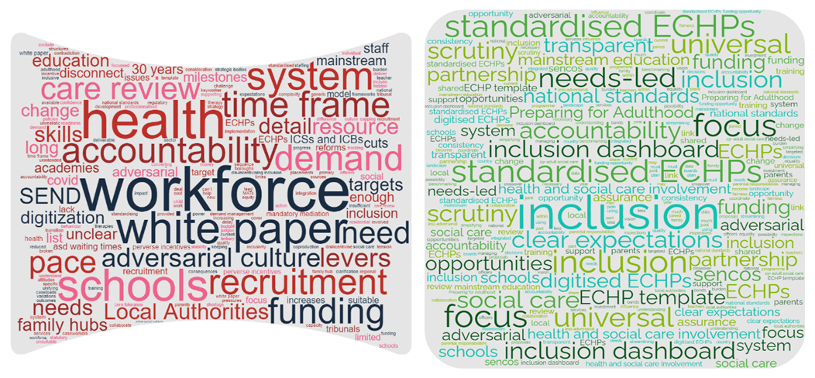
The above word clouds show key themes mentioned at the summit. Challenges are in red and opportunities are in green.
Next Steps
The consultation period for the SEND Green Paper ends on the 22nd July. ALDCS will be submitting a response based on feedback heard at this summit and from other key stakeholders, but we urge everyone with an interest in improving the SEND system for children and families to submit their own response. Responses can be submitted here: https://consult.education.gov.uk/send-review-division/send-review-2022/consultation/subpage.2022-02-02.7538639008/
For anyone who was unable to attend, presentations by Andre Imich, Peter Nathan, Sophia Njiri and Fazilla Amide can be found on the LIIA website, along with a recording of those speakers. Gaynor’s presentation is not available to the public. We welcome further comments from anyone who was unable to attend the summit but would still like to help us develop the ALDCS response to Green Paper consultation. Please send comments to: vita.bax@londoncouncils.gov.uk
The work done at the London SEND Summit will also be used to inform the London SEND Plan 2022-25, which is currently being drafted by Frank Offer, LIIA. Please do get in touch if you would like to add your comments to the plan and influence the work taken forward in London over the next three years (vita.bax@londoncouncils.gov.uk).
LIIA will be holding further events in the future for staff working in SEND. We plan to link future events to key developments in legislation and will aim to hold these events approximately annually. Please look out for our next event, which we are expecting to hold in January/February 2023. Possible topics for future events can be found in appendix 2.
Appendix 1: SEND Green Paper: The London SEND Summit View
Delegates at the SEND Summit engaged in lively discussion about proposals contained in the SEND Green Paper. In discussion, delegates were asked to note down the opportunities and challenges they felt were raised by the SEND Green Paper. It is interesting to note how many of the same themes appear as both opportunities and challenges. Particular examples are the themes of inclusion, accountability, and funding. It seems clear that London stakeholders reserve judgement on the value of many of the new proposals until further detail is confirmed about how these ambitions will be implemented. Many delegates expressed concern that although the ambitions contained in the Green Paper were admirable and usually welcome, their implementation was not sufficiently worked out to inspire complete confidence. Of particular concern was the extent of proposed changes coupled with limited funding commitments.
Delegates also were unclear on the relationship between proposals contained in the SEND Green Paper and targets set in the Education White Paper, which was released by the Department for Education one day before the Green Paper. While the Green Paper sets ambitious targets for inclusion of children and young people with SEND in mainstream schools, the Education white paper set a target of 90% of primary school children to achieve the expected standard in Key Stage 2 reading, writing and maths by 2030. This appears in tension with the aim of encouraging more young people with SEND into mainstream schools, as this could push the percentage of pupils reaching this level of attainment down. This puts schools in a challenging position, as some may exclude or be reluctant to take children with SEND to meet the stringent targets set for attainment. At the same time, the schools will be encouraged by their local authority to admit more children with SEND. It seems clear that there needs to be more joined up thinking to deliver on the ambitions for increased attainment and greater inclusion. The role of local authorities in encouraging schools to prioritise inclusion links to a broader concern about the extent to which local authorities have been given the levers over other organisations and partners which are necessary to implement the new proposals.
Delegates also expressed concerns about the state of the SEND workforce. The children’s workforce in general is suffering from a failure to recruit the numbers of staff needed, a high turnover which erodes relationships and skills, and an over-reliance on agency workers who do not always provide the quality of service which young people and families should receive. Without serious investment in the workforce, it is hard to see how the ambitious proposals contained in the Green Paper can progress. Delegates welcomed the new qualification for SENCos but hope to see this development as part of a wider package of investment in the workforce, including mainstream teaching staff as well as specialist providers, local authority employees, and clinicians.
Despite these unanswered questions, delegates were cautiously optimistic about many of the proposals contained in the review. The decision to digitise and standardise the template for Education Health and Care Plans was welcomed, as it supports local authorities to respond to criticisms in Ofsted inspections regarding the variable quality of ECHPs. National standards for the quality and type of services available to young people were also welcomed by many delegates, with the caveat that this should act as a lever to hold the local SEND partnership to account and justify funding where needed, rather than to penalise areas which are unable to meet the standards through a sheer lack of resource. In general, a focus on partnership working and a clear ambition to join up education, health, and social care was welcomed. If these relationships can be managed effectively, then this will help achieve the best outcomes for children across all areas of their life. Therefore, we once again return to the question of how these proposals will be managed. Accountability and control must be shared out to the right parts of the SEND partnership, and ambitions must be followed by sufficient funding.
Currently, whilst the SEND system works well in some aspects and some areas, in many places (as acknowledged in the Green Paper) it is damaged by adversarial relationships – especially between parents who feel they are being let down and local authorities who feel stretched beyond their budgets to provide services. Delegates felt that change to this adversarial culture is fundamental if we want to see these proposals work. This culture change is beyond legislation, but it seems clear that the first step must be increased funding and upskilling for service providers and local authorities, so they are able to offer children and families the quality of support which is needed. This is fundamental to build trust between services and families.
Delegates at the London SEND Summit welcome central government’s energy and ambition and urge the Department of Education needs to ensure pace. In this context, the timeframe for the implementation of the new proposals was felt to be insufficiently ambitious, with not enough milestones agreed in the short and medium term. In general, delegates have been frustrated with the pace of the SEND Review and hope that the release of the Green Paper will kickstart a period where we can see real progress being made for children and families.
By adding their voices to the consultation, delegates hope they can encourage central government to commit more in terms of funding and support, as well as consider their more specific concerns and suggestions. There is huge value in recognising the scale of the challenge facing the SEND system, and delegates applauded the Green Paper for this. However, central government’s ambitions need to be matched by more resource and more detail, so that families and children with SEND can benefit from the proposals.

Appendix 2: Delegate Feedback on the Summit

We received 42 responses to the feedback forms which were distributed at the SEND Summit. Most feedback we received was very positive, with 38 respondents saying that the event was helpful in clarifying their views on the SEND Green Paper and new Ofsted Inspection Framework, and a further 4 saying the event was mainly or generally helpful.
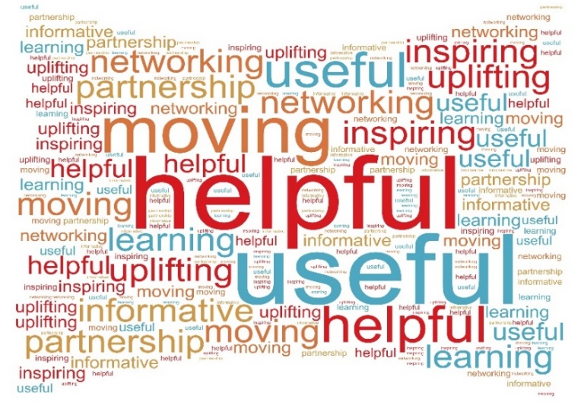
According to the respondents, standouts of the day were Fazilla Amide’s talk on the parent/carer response to the SEND Green Paper and the presentation by Gaynor Roberts on the new Ofsted framework. Many participants also noted the groups discussion sessions and the panel on the Green Paper as highly informative and enjoyable.

Words used to describe the London SEND Summit.

Group Discussions
34 respondents said that they were able to participate fully in the group discussions, and that they were able to discuss what they felt was important. We should ensure that all future events have opportunities for delegates to interact and work together on tasks. 3 respondents noted that the room was very loud, and that this made the discussions harder to participate in. In future, we may wish to use a larger space, or consider holding discussion sessions in separate breakout rooms.
In Person or Online?
27 respondents said they would prefer in-person events to online events in the future. However, 16 responded that they would prefer to have both options available. This included suggestions for a limited number of in-person events per year, interspersed with more regular online events, hybrid events, and different events for different purposes. One respondent suggested that in-person events were preferable for discussion, while online events worked better to distribute information.
Key Learning
The most common issue raised by respondents was the lack of time or having to rush, particularly for the group discussions. In the future, we will endeavour to leave more time for group discussions or offering more ‘networking’ opportunities throughout the day. We will also seek to time the event to fit better for people with childcare commitments.
Suggestions for Future Events
- Workforce
- Alternative Provision
- New Inspection Framework - Consolidation
- Youth Offending, Education, and SEND
- Follow up on Green Paper post Consultation Period
- Joint Working of Education, Health Social Care
- ASD Incidence and Diagnosis
- Recently Released Social Care Review
- Managing Culture Change
- Coproduction
- Housing and SEND
- ECHPs and Digitisation
Appendix 3: List of Delegates
First Name | Surname | Borough/Organisation
Zulkifl | Ahmed MBE | Enfield
Seyi | Akinsanya | Lambeth
Elaine | Allegretti | Barking and Dagenham
Fazilla | Amide | NNPCF
Amalia | Banon | Sutton
Charles | Barnard | Ealing
Maria | Blanchard-Rowe | Southwark
Sharon | Buckby | Brent
Jacquie | Burke | Hackney
Nigel | Chapman | Brent
Owen | Chiguvare | Barnet
Anna | Chiva | AfC
Debi | Christie | Bromley
Stephanie | Connelly | Newham
Trevor | Cook | Havering
Annita | Cornish | Hounslow
Sharon | Cushnie | City of London
Mala | Dadlani | Lewisham
Shelley | Davies | Croydon
Dorett | Davis | Lewisham
Emma | Dawn | Hounslow
Jackie | Difolco | Haringey
Santokh | Dulai | Harrow
Tiffany | Elliott | Wandsworth
Richard | Ellis | Merton
Julie | Ely | Kensington and Chelsea
Martine | Eni | Sutton
Karla | Finikin | Merton
Andy | Fish | Wandsworth
Elizabeth | Fitzpatrick | Merton
Karen | Flanagan | Camden
Samantha | Gager | Towerhamlets
Victoria | Gatley | Redbridge
Eva | Gunkova | Waltham Forest
Wesley | Guy | Bexley
Johanna (Hanna) | Hancock | Southwark
Lisa | Harvey | Havering
Patricia | Harvey | Merton
Peter | Haylock | Hammersmith and Fulham
Ying | Herng | Ealing
Troy | Hobbs | AfC
Candy | Holder | Islington
Candy | Holder | Islington
Jilul | Hoque | Redbridge
Liz | Hunt | Redbridge
Andre | Imich | Department for Education
Mary | Jarrett | Haringey
Deborah | Johnson | Wandsworth
Dominique | Johnston-Franklin | Lambeth
Linda | Jordan | NDTI
Jessica | Juon | Newham
Jane | Knowles | Sutton Parent-Carer Forum
Zarah | Lowe | Hounslow
Josephine | Lyseight | Haringey
Emma | Maffre | Wandsworth
Alison | Markwell | NHS
Jodi | Mathers | Greenwich
Michael | McKeaveney | Barking and Dagenham
Jacqui | McShannon | Hammersmith and Fulham
John | Miller | Bexley
Catherine | Milmine | Harrow
Sarah | Moore | City of London
Peter | Nathan | Enfield
Sophia | Njiri | NHS
Chike | Nnalue | Ealing
Peter | O'Brien | London Councils
Patrick | O'Dwyer | Harrow
Reinhild | Onuoha | Bexley
Linda | Orr | Barnet
Debbie | Orton | Department for Education
Di | Osbourne | Greenwich
John | O'Shea | Tower Hamlets
Lauren | Ovenden | Waltham Forest
Natasha | Patten | Kensington and Chelsea
Fabiola | Peacock | Ealing
Fiona | Phelps | Sutton
Abrilli | Phillip | Lambeth
Traci | Pope | Haringey
Sam | Powell | Merton
Martin | Pratt | Camden
Charles | Quaye | Croydon
Amanda | Quincey | Bromley
Victoria | Redgrave | Lewisham
Kathy | Roberts | Croydon
Gaynor | Roberts | Ofsted
Satwinder | Saraon | Hammersmith and Fulham
Angela | Scattergood | Lewisham
Theresa | Shortland | City of London
Sonal | Sisodia | Hillingdon
Brian | Smith | Haringey
Peta | Smith | Bromley
Robert | South | Havering
Anita | Stewart | Newham
Alison | Stewart | AfC
Eve | Stickler | Camden
Karen | Street | NNPCF
James | Thomas | Tower Hamlets
Steven | Trowbridge | NHS
Roz | Weeks | Greenwich
Claire | Wicks | Lambeth
Nick | Wilson | Hackney
Joe | Wilson | Hackney
Frank | Offer | LIIA
Rula | Tripolitaki | LIIA
Serina | Mehmi | LIIA

