The Pan London Care Leavers Compact Transport for London Concession for London’s Care Leavers aged 18-25

Background
The Pan London Care Leavers Compact brings together a series of partner commitments to London’s Care Leavers to increase the consistency and quality of the support they receive. Care Leavers (and numerous research bodies) point to transport costs as a critical factor in their lives. Transport costs are not only a financial burden for a cohort that is already financially disadvantaged, but also a barrier to securing and sustaining education and employment, accessing health and wellbeing services, and sustaining the supportive relationships that are so important for our care experienced community.
In response to this need, the Mayor of London made a 2021 manifesto pledge to introduce half-price travel for Care Leavers.
The Concession
Transport for London are introducing half price travel on buses and trams. The offer and eligibility criteria are as follows:
- The concession offers 50% reduction in adult travel fares on TfL buses and trams
- It is for London Care Leavers aged 18-25 (up until their 26th birthday).
- Care Leavers are as defined by section 2(7) of the Children and Social Work Act 2017.
- Care Leavers must have been in care with a London local authority, who remains the responsible authority for them
- The primary address at time of application is in London
Other concessions may be more beneficial
We believe the TFL Concession for Care Leavers will financially benefit the majority of Care Leavers who live in London. However, as only one TfL travel discount can be held at a time, Care Leavers falling into the following categories may need to decide which offers the greatest benefit at any given point in time.
Job Centre Plus – Offers 50% discount on Buses, Trams and Travelcards
Apprentice Discount – Offers 30% discount on Buses, Trams and Travelcards
18+ Student – Offers 30% discount on Buses, Trams and Travelcards

More information on these concessions can be found here: https://tfl.gov.uk/fares/find-fares/bus-and-tram-fares

The Application Process Overview – a two-step process for Care Leavers
Issuing the concession requires a check to be made of the Care Leaver’s eligibility, including their care leaver status. This requires a two-step process where eligibility is confirmed with Local Authorities before an application is made on the TfL website. There are an estimated 16,000 18-25 year old London Care Leavers; the scheme has been designed to maximise efficiency for the applicant, Local Authorities and TfL.
- The Care Leaver informs their Local Authority (LA) they want to apply for the concession, agreeing that the Local Authority will share their first and surnames, DOB, and LA Child ID with LIIA and TfL
- The Local Authority collates details of its Care Leavers who want to apply. LIIA will provide an excel workbook template to sit with a SPOC in the LA data team on which the details of the Care Leavers are entered.
- Every two weeks a SPOC in the LA data team passes details of these Care Leavers to LIIA by depositing the excel workbook in a LA user specific folder on the secure London Data Platform. (Prior to the platform being ready the excel workbook can be sent directly by secure email to a named contact in the LIIA team).
- Within one week of workbook receipt, LIIA passes collated details of all London Care Leavers wanting to apply to TFL via a secure upload to the TfL system
- Three weeks*, or later, after their initial expression of interest, the Care Leaver makes their application via the TfL website for the 18-25 CL Bus & Tram discount scheme. The full name / DOB must be an exact match to the details provided by the LA. Further details of the website application process are in Appendix 2 below.
- An automated verification is done of the website application details against the data provided by the LA. Following a match, the Care Leaver will be asked to upload a photo to be visible on the Oyster photocard. This can be done by smartphone.
- The Care Leaver will need to pay an administration fee of £20 by debit/credit card to complete the application process. This is a one-off payment that lasts the length of the concession (till 26th birthday). If the concession card is lost, a replacement is charged at £10. The payment may be made by another party (e.g. a local authority) provided the debit/credit card is registered at a London address.
- The personalised Oyster photocard is sent by post to the Care Leaver’s address within two weeks of payment.
*The exception for this is at the launch of the scheme, where the TfL website application should not be made until the formal launch date is passed.
Unverified Applications
An application will not progress for the following reasons:
- The name and DOB data provided by the applicant and the LA do not match
- The TfL website application has been made before the LA data has been uploaded to the TfL system (allow three weeks from the Care Leaver’s expression of interest)
- The application indicates ineligibility based on the criteria for the scheme, e.g. The address provided does not fall in a London borough, the young person is aged under 18 or over 26 years old.

If an application is unverified, a TfL website message indicates the application has been unsuccessful and they are directed back to their responsible Local Authority for advice and support. An email will also be sent to the applicant’s registered email address.
Launch date and the initial upload
The launch date for the new concession will be in January ‘24 (date TBC).
It is anticipated that the first upload of Care Leavers wanting to apply will be the largest. Local Authorities will have around six weeks before the concession’s launch to communicate the scheme to their Care Leavers and collate expressions of interest. This should enable them to get the view/position of most of their existing 18-25 Care Leavers.
After the initial launch, most applications will be from Care Leavers turning 18 or those who have been out of touch and are now wanting to access the scheme. These are anticipated to be much lower numbers than the initial upload, meaning that the ongoing running of the scheme is not too onerous.
Information Governance
LIIA are producing the information governance documentation working with colleagues in the Information Governance for London group (IGfL). There is a well-established method of working, which LIIA have used for several projects; a small group of IGfL members scrutinize the documentation in detail, request changes from LIIA and then re-examine the documents until they are satisfied that the process and safeguards in place meet their rigorous requirements and can be approved on behalf of IGfL.
Once approved, a Data Sharing data flow is created on the Information Sharing Gateway (ISG) and each signatory for each London Authority and all Data Processors can sign-off the agreements.
Once a signatory has signed the agreement on ISG, data sharing can commence.
The initial meeting with IGfL happened at their meeting on 8th November 2023. Agreement was subsequently reached with TfL that there will be one Information Sharing Agreement. This has been reviewed by one DPO and approved on behalf of IGfL. The agreement has been placed on the Information Sharing Gateway for sign off.
The Wider Local Authority role
Communication
The Local Authority has a key role to play in ensuring Care Leavers are aware of the new concession and can make an informed decision. Research indicates that there are problems in connecting Care Leavers with the support that is available to them. Linking the concession with the LA’s ‘local offer’, and making use of relationships with Personal Advisors, the LA can connect care leavers with this support. This in turn depends on Leaving Care teams and the wider workforce having good knowledge of the concession.
The concession will also be promoted regionally by the Mayor/GLA and by LIIA through the Care Leavers Compact.
Support of Care Leavers to apply
Whilst the application process is designed to be as straightforward as possible, Care Leavers may need individual support, for example in:
- Understanding the concession fully
- Understanding that the LA will share their name/DOB
- Understanding the two-stage application process
- Completing the application process, uploading the photo, and (at LA’s discretion) funding the one-off admin fee
- Support in the event of an application being unverified
- Being aware that any fraudulent use of the card – e.g. lending it to a friend, may result in the card/concession being stopped
Local Authority considerations in administering the concession
Local Authorities decide who does what across CL admin and data teams in terms of promoting the scheme and collating data for interested Care Leavers. An exception is that LIIA requests a SPOC in the data team to manage the fortnightly upload. Embedding the concession offer into wider practice, for example pathway planning and transition support, should allow it to become routine, preventing delay in accessing the scheme for the Care Leaver and enabling LA’s to plan ahead in collating names and uploading them.
We also recommend that the list is reviewed by Local Authorities on a regular basis and where a Care Leaver remains on the list without a successful application, this is followed up as appropriate.

Appendix 1: The Data sharing process in more detail

The long-term process will be as follows;
The data submitted by the Local Authority will include personal data about:
- young people who are Care Leavers or will become care leavers in the next three months

Personal data to be shared:
- first name and surname
- date of birth
- responsible Borough
- responsible Borough child ID

The local Authority collates the data about the care leavers who wish to take up this TfL concession on the Excel workbook provided by the LIIA D&I team.
[Please Note: It’s important that this workbook is not changed or altered because the code that collates the data into the format required by TfL will not function correctly if the layout, formatting etc are changed. This will then lead to the Care Leaver not being verified and being unable to claim the concession to which they are entitled. If there are any problems please contact the LIIA D&I team.]

Every fortnight by 10:00 on Friday, the workbook needs to be uploaded to the London Data Platform.

Uploading data
The Data Team SPOC (or officer responsible for submitting the data in the data team) will be given access to a private folder on the London Data Platform and uploads the data into this folder. This folder is only accessible by authorised personnel from the LA and the London Data Platform IT maintenance team.

What happens Next
A script is trigged to run within the London Data Platform environment to do the following:
- Assess data quality (missing values, incorrect formats)
- If appropriate, perform other functions e.g. remove applicants who have already successfully applied for the TfL concession [So that there is no unnecessary data sitting on the TfL system – the code will use the child ID to identify the young people to be removed which is why we collect this]

An additional process within the London Data Platform environment merges the datasets from all CONTROLLERS into a single pan-London dataset in csv format.

A member of the D&I team then uploads that combined csv file via a secure virtual machine (VM) into a folder on the TfL system created specifically for this concession with access limited to the LIIA d&I team and limited TfL staff.
An automatic function then takes the submitted file and creates a new data table in the format required for verifying the applications – this data table is the responsibility of TfL.

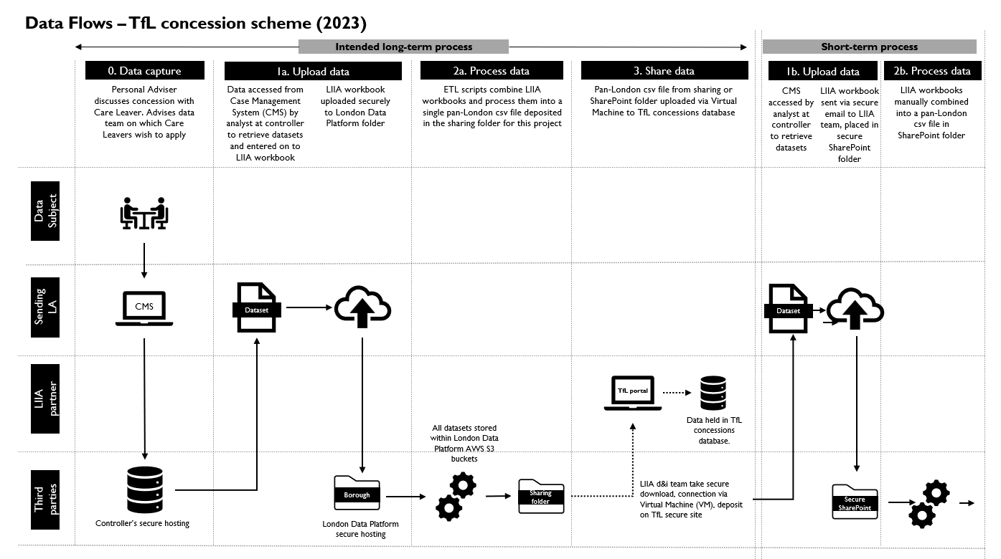

Appendix 2
TfL Website Application process
The care leaver must apply online via the photocard portal on the TfL website https://photocard.tfl.gov.uk/
The care leaver will need to select ‘Create an Oyster photocard account’ to set up a photocard web account through which they can apply for the concession. If the care leaver already has an account, they can sign in with their current email address and password.
During the creation of the photocard web account the care leaver will need to provide the following details (these personal details will also contribute to the application record itself):

- Date of birth
- Title
- First name and Surname (this must exactly match the spelling in the LA workbook upload)
- Email address
- Selection and confirmation of a password for the web account
- Selection of whether UK resident
- Borough (This is a reference to the borough the applicant lives in and not their responsible borough as a care leaver, which is requested later as part of the application)
- London address. This is also where the card will be posted to if the applicant is successfully validated)
- Phone number
- Selection of a security question and answer that will be registered against the account and photocard for security purposes (the security question options available are mother’s maiden name, memorable date or memorable place). TfL is mindful that, for some, mother’s maiden name may be an issue. They can choose a different option or they can treat this as a free text field where they can select any memorable word they want (not exceeding 18 characters). If they need to contact TfL about their card they will be asked for confirmation of this answer as a primary way to identify them as the registered card holder.
- Once the care leaver has entered the information stated above, they will need to select ‘Create account’. At this point the account itself will require activation. An email will be sent to the email address provided by the care leaver and will contain a link that needs to be clicked to activate the account.
- Once the web account has been created and activated, when the care leaver signs into the account, a confirmation message will appear, and the care leaver will be able to select to ‘Apply for a card’. If they already had an existing web account they will also see the option to ‘Apply for a card’ once logged in.
- The care leaver will need to specify that they are applying for themselves (and not someone else) via a drop-down menu they select from.
- At this point the care leaver will be presented with the photocard schemes available to someone in their age group of 18-25. The care leaver will need to select ‘Apply now’ for the ‘18-25 CL Bus & Tram Discount Oyster photocard’

From here, to progress the 18-25 CL Bus and Tram Discount concession, the Care Leaver needs to:

- Review their details on the review page (name, date of birth and address details to ensure they are correct)
- Enter their Responsible London Borough. (The care leaver will select this from a drop down list of London boroughs then select the ‘Next’ button to progress and it is at this point where the check against the LIIA workbook data provided by the boroughs will occur.)
- If successfully verified, the care leaver can continue on screen, and they will be asked to provide a digital photo of themselves which must be a .jpg, .bmp or .gif file and be less than 6MB
- Enter details of a debit or credit card registered at a London borough address and pay £20 ( The name on the payment card doesn’t have to match the applicant, it just has to be registered at a London address.)
- Once the photo has been accepted as meeting TfL standard requirements, the 18-25 CL Bus & Tram Discount Oyster photocard will be produced and dispatched, arriving within two weeks. Often, it is much quicker - within 5 working days.
- Unverified applicants whose data could not be matched will see an onscreen prompt and receive an email directing them to their responsible borough/personal advisor if they need more help. These applicants will not be able to complete an application.

